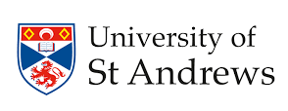

Health, Risk and Communities Nexus (HRCN) symposium 3rd of October 2025
Location: Parliament Hall, University of St Andrews

Symposium program:
9.45 - 10.10 am: Registration and coffee
10.10 – 10.20 am: Opening and a word about the Fora and what have been done (Speaker: HRCN convenor - Dr Mary Abed Al Ahad)
10.20 am – 12.00 PM: Flash presentations from Fora members about their research (3 minutes presentation + 2 minutes for questions)
12.00 – 12.15 PM: Coffee break
12.15 – 1.00 PM: Keynote speaker
1.00 – 2.00 PM: Lunch break
2.00 – 3.30 PM: Afternoon workshop on how to shape the HRCN Fora and contribution to a collaborative academic/policy piece of evidence.
3.30 – 3.45 PM: Comfort break
3.45 – 5.00 PM: A historical walking tour around St Andrews (Visit St Salvator Quad, the cathedral ruins, the castle, ending it at the East Sands Pier).
5.00 – 7.00 PM: Networking dinner at a local restaurant

